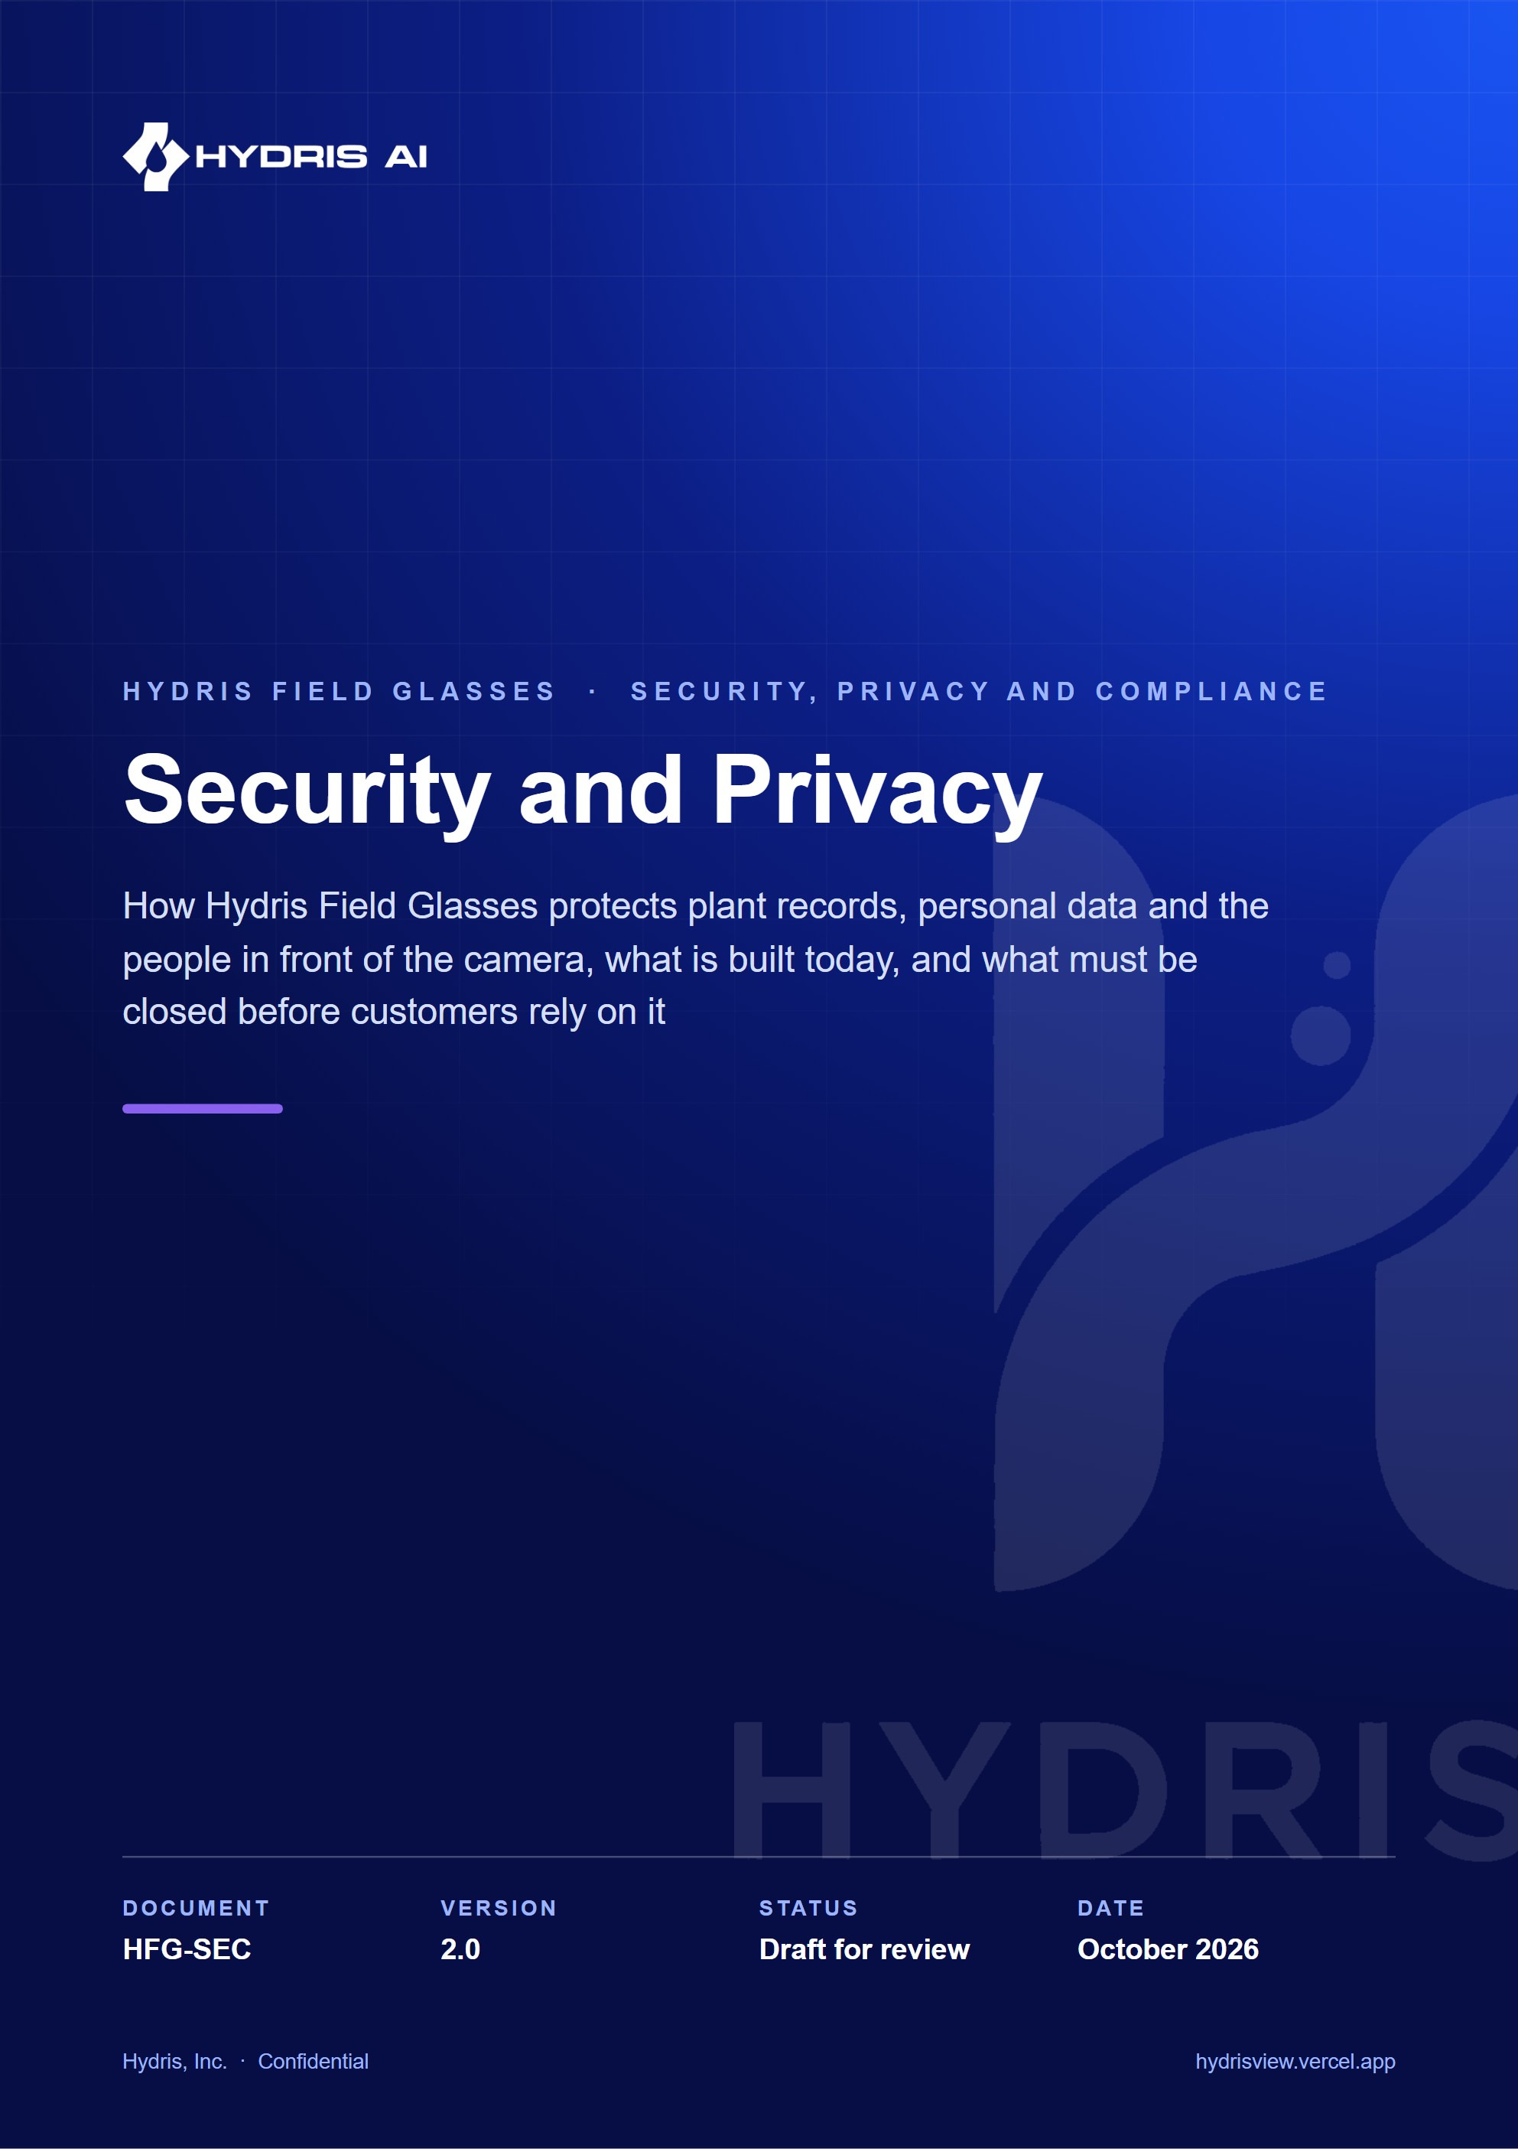
Document control
Document | Security and Privacy (HFG-SEC)
Version | 2.0
Status | Draft for review
Owner | Security, Hydris
Audience | Security reviewers, platform and mobile engineers, customer IT, OT and compliance teams, data protection officers, pilot leads
Product | Hydris Field Glasses: website, operator console, glasses app, Android app, API
Source of truth | docs/product/SECURITY_PRIVACY.md in tarun-km/hydrisview (this Word file is generated from it)
Classification | Confidential: Hydris, Inc. and named partners
Revision history
Version | Date | Author | Changes
2.0 | October 2026 | Security, Hydris | Rewritten as a full security and privacy reference. Adds data flow with trust boundaries, STRIDE per component, session and pairing sequences, RBAC and RLS detail, mobile and AI safety, bystander and worker privacy, compliance mapping, retention, incident response and a risk-rated gaps register

Contents
1 Security principles 5
2 System overview and trust boundaries 7
3 Data classification 8
4 Threat model 9
4.1 Web console and authentication 9
4.2 Glasses runtime and bridge app 9
4.3 Native Android app 10
4.4 API, database and ingest 10
4.5 AI provider and cron 10
5 Authentication and sessions 11
5.1 Tokens in use 11
5.2 Sign-in with MFA 12
5.3 Refresh rotation and reuse detection 12
6 Device and glasses security 14
6.1 Pairing 14
6.2 Device lifecycle and lost devices 15
7 Authorization 16
7.1 Roles and permissions 16
7.2 Layered enforcement 17
7.3 Row-level security 18
8 API security 19
9 Secrets management 20
10 Mobile security 22
11 AI safety 23
11.1 What is sent to Anthropic 23
11.2 Controls 23
12 Camera and bystander privacy 25
13 Worker privacy and monitoring ethics 27
14 Compliance mapping 28
15 Retention schedule 29
16 Audit logging 30
17 Vulnerability management 31
18 Incident response 32
19 Security roadmap 34
20 Known gaps register 35

Hydris Field Glasses puts live plant data, procedures, audit-record scanning and a voice assistant into the hands (and the field of view) of wastewater and effluent treatment operators. That makes it a system of record for regulated environmental data, an identity system for plant staff, and a camera worn in an industrial workplace. This document describes how each of those responsibilities is met.
Statements about the current product name the file that implements them. Status follows the house rule: Built (in the code and exercised), Partial (exists with a known gap) and Planned (designed, not implemented). Compliance entries are mappings and targets, never claims of certification.
3  layers of access control  RBAC, site scope and Postgres row-level security |  | 15 min  access token lifetime  refresh tokens rotate with reuse detection |  | 0  write paths to plant control  Hydris is read-only to PLC, SCADA and DCS |  | 2  people per approved audit record  verifier and a different approver

IMPORTANT
The public demo at https://hydrisview.vercel.app runs in demo mode with public signing secrets and synthetic data (apps/api/src/config.ts). Its security properties are deliberately weaker and are listed in this document. Real plant data must only ever be placed in a production deployment (see HFG-DEP).

1 Security principles
- Read-only to the plant. No endpoint writes to PLC, SCADA or DCS. Telemetry arrives by outbound push from a gateway (POST /api/ingest/v1/readings). The voice assistant prompt states that Hydris never operates equipment (apps/api/src/modules/voice-assistant.ts).
- Defence in depth for tenancy. Permission checks in the API, site scoping in queries, and row-level security in Postgres, so one missing check does not leak another customer's data.
- Records are evidence. Audit trails are append-only at the database grant level; corrections preserve the original value; audit documents need two different people.
- Least privilege for devices. Glasses act for one assigned operator with a fixed permission ceiling and can be suspended or revoked instantly.
- Secrets are never stored in the clear. Passwords use argon2id; refresh, device, gateway, invitation and reset tokens are stored as SHA-256 hashes; MFA seeds are AES-256-GCM encrypted.
- AI assists, people decide. AI output is grounded in tenant data, labelled, cross-checked and verified by humans before it becomes a record.
- Capture on intent only. The camera captures when a person asks it to. There is no continuous recording.
- Privacy by default. Collect the minimum personal data, keep it in the customer's jurisdiction, and delete it when its purpose ends.
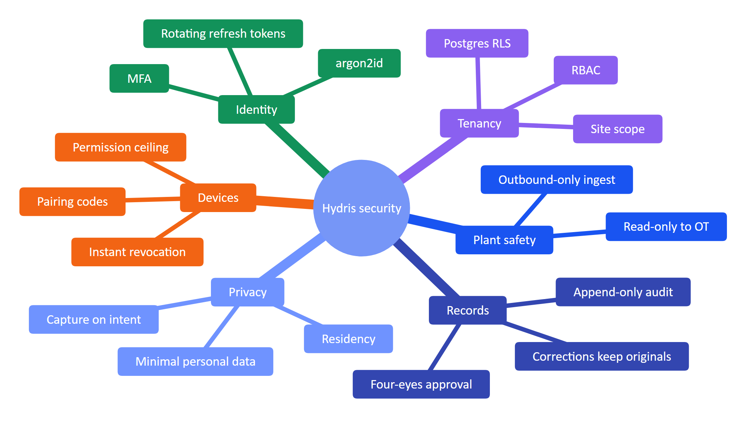
Figure 1. Security and privacy principles grouped by concern

2 System overview and trust boundaries
The data flow diagram shows every component that handles customer data and the trust boundaries between them. A trust boundary is anywhere data crosses from a party or runtime we do not control to one we do, or the reverse.
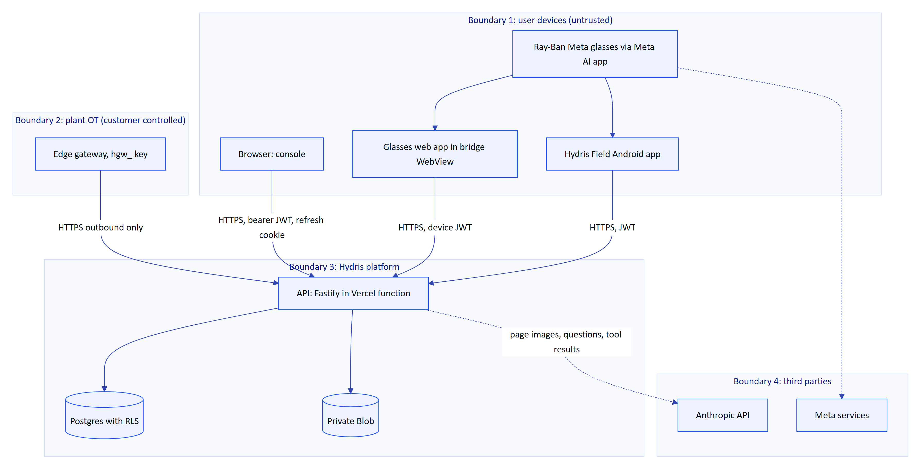
Figure 2. Data flow diagram with trust boundaries
Boundary | Crossing | Main controls
Devices to platform | All user and glasses traffic | TLS, JWT verification, revocation check per request, rate limits, zod validation
Plant to platform | Telemetry batches | Hashed gateway key, outbound-only, 500 readings per call, site-restricted sensors
Platform to database | Every query | Transaction runs as hydris_app with app.org_id; RLS forced
Platform to Anthropic | Audit page images, voice questions and tool results | Only when a key is configured; per-org opt-out Planned
Glasses to Meta | Camera, microphone, button events through DAT | Vendor platform; disclosed as a subprocessor

3 Data classification
Table 1. Trust boundary crossings
Class | Examples | Where stored | Handling rules
Restricted secrets | Password hashes (argon2id), MFA seeds (AES-256-GCM with DATA_KEY), refresh, device, gateway, invitation and reset token hashes, JWT_SECRET, DATA_KEY, CRON_SECRET | Postgres, platform secrets | Never logged, never returned; raw tokens shown once
Regulated operational records | Telemetry, corrections, alarm history, inspections, maintenance, audit documents and their events | Postgres, Blob | Tenant RLS, append-only trails, retention per permit
Personal data | Names, emails, IPs in auth_sessions and audit_events, device last_ip, website inquiries (IP stored as a salted hash) | Postgres | Minimise, DPDP and GDPR rights, short retention outside records
Sensitive imagery | Page photos that may show signatures, names, faces or the plant | audit_document_pages, attachments | Capture on intent, authorized routes only, no public URLs
Voice content | Question text after "Hey Hydris" | Request body only, not persisted by /assistant/ask | Audio never uploaded to Hydris
Device-cached data | Glasses context cache and offline queue in localStorage (apps/web/src/glasses/data.ts, link.ts) | Phone browser storage | Cleared on logout; encryption Planned
Public | Website content, product documentation | Web | None

4 Threat model
The threat model uses STRIDE per component. "Controls" lists what is in the code; "Gaps" lists what is missing.

4.1 Web console and authentication
Table 2. Data classification
Threat | Scenario | Controls | Gaps
Spoofing | Password guessing, credential stuffing | argon2id (core/crypto.ts), lockout after 5 failures for 15 min, login limit 10 per min, timing-equal dummy verify, optional TOTP | No breached-password check, no SSO, MFA not enforceable per org
Tampering | Changing role or org in a token | JWT signed with JWT_SECRET; membership and role reloaded from the database on every request (context.ts) | None known
Repudiation | Denying a change | audit_events with actor, IP and action; append-only grant | No hash chain or WORM export
Information disclosure | Cross-tenant reads, user enumeration | RLS, 404 for out-of-scope records, identical reset responses | CSP disabled in helmet (contentSecurityPolicy: false)
Denial of service | Login floods | Rate limits, 1 MB body limit | Limits are per function instance
Elevation of privilege | Manager invites an admin | assignableRoles (packages/domain/src/roles.ts) | None known

4.2 Glasses runtime and bridge app
Table 3. STRIDE for the web console and authentication
Threat | Scenario | Controls | Gaps
Spoofing | Rogue device pairs into an org | Pairing requires a signed-in user with device.pair to approve a short code; poll secret hashed | Code TTL 300 s, no device attestation
Tampering | Injected page calls native bridge | Bridge loads only BuildConfig.HYDRIS_URL + "/glasses" | Default WebViewClient allows navigation elsewhere with HydrisNative still exposed; onPermissionRequest grants everything
Repudiation | "The glasses did it" | Audit events record actorDeviceId and assigned user | None known
Information disclosure | Stolen phone exposes refresh token | 30-day device sessions, revocation | Web runtime keeps the device refresh token in localStorage
Denial of service | Pairing spam | 10 challenges per min, 40 polls per min | Per-instance limits
Elevation of privilege | Device calls admin endpoints | DEVICE_PERMISSIONS ceiling (core/principal.ts); verify and approve require a user principal | None known

4.3 Native Android app
Table 4. STRIDE for the glasses runtime
Threat | Scenario | Controls | Gaps
Information disclosure | Token theft from storage or backup | AES-256-GCM with a non-exportable Android Keystore key (SecureStore.kt); allowBackup="false" | No user-authentication binding on the key
Tampering | Man-in-the-middle on hostile Wi-Fi | System TLS validation | Certificate pinning Planned
Spoofing | Repackaged app | Play signing (Planned) | Release currently signed with the debug key; no Play Integrity

4.4 API, database and ingest
Table 5. STRIDE for the native app
Threat | Scenario | Controls | Gaps
Spoofing | Forged gateway | hgw_ keys hashed, gateway and org must be active | No key expiry or IP allow-list
Tampering | Silent edit of readings | Corrections in append-only telemetry_corrections; original kept | No signed export
Information disclosure | SQL leak across tenants | withTenant sets role and org per transaction, FORCE RLS | Owner connection would bypass RLS; separate runtime user Planned
Denial of service | Ingest flood | 1,200 calls per min per instance, 500 readings per call | Shared limiter Planned
Elevation | Code path forgets withTenant | withSystem still runs as hydris_app with append-only grants | Review checklist only

4.5 AI provider and cron
Table 6. STRIDE for the API, database and ingest
Threat | Scenario | Controls | Gaps
Information disclosure | Plant documents sent to a third party | Only with a configured key; images sent per request | Per-org opt-out Planned; no zero-retention agreement recorded
Tampering | Prompt injection in a scanned page | Structured output schema, cross-check against on-device OCR, human review | No explicit injection classifier
Spoofing | Unauthenticated cron calls | CRON_SECRET bearer compared with timingSafeEqual | None known

5 Authentication and sessions

5.1 Tokens in use
Table 7. STRIDE for the AI provider and cron
Token | Format | Lifetime | Storage (client) | Storage (server) | Revocation
User access token | JWT typ: user with sid family | 15 min (12 h in demo) | Memory | None | Family revocation checked per request
User refresh token | 48 random bytes | 7 days | hg_refresh cookie, HttpOnly, SameSite=Strict, path /api/auth, Secure in production | SHA-256 in auth_sessions | Logout, password change, reuse detection, session list
MFA challenge | JWT typ: mfa | 5 min | Memory | None | Expiry
Device access token | JWT typ: device with sv session version | 15 min | Memory | None | session_version bump
Device refresh token | hgd_ plus 40 random bytes | 30 days | Keystore (native) or localStorage (web) | SHA-256 in device_sessions | Revoke, suspend, logout, reuse detection
Gateway key | hgw_ random | Until revoked | Gateway config | SHA-256 in gateways | POST /gateways/:id/revoke
Invitation and reset tokens | Random | 7 days and 30 min | Link | SHA-256 | Single use

5.2 Sign-in with MFA
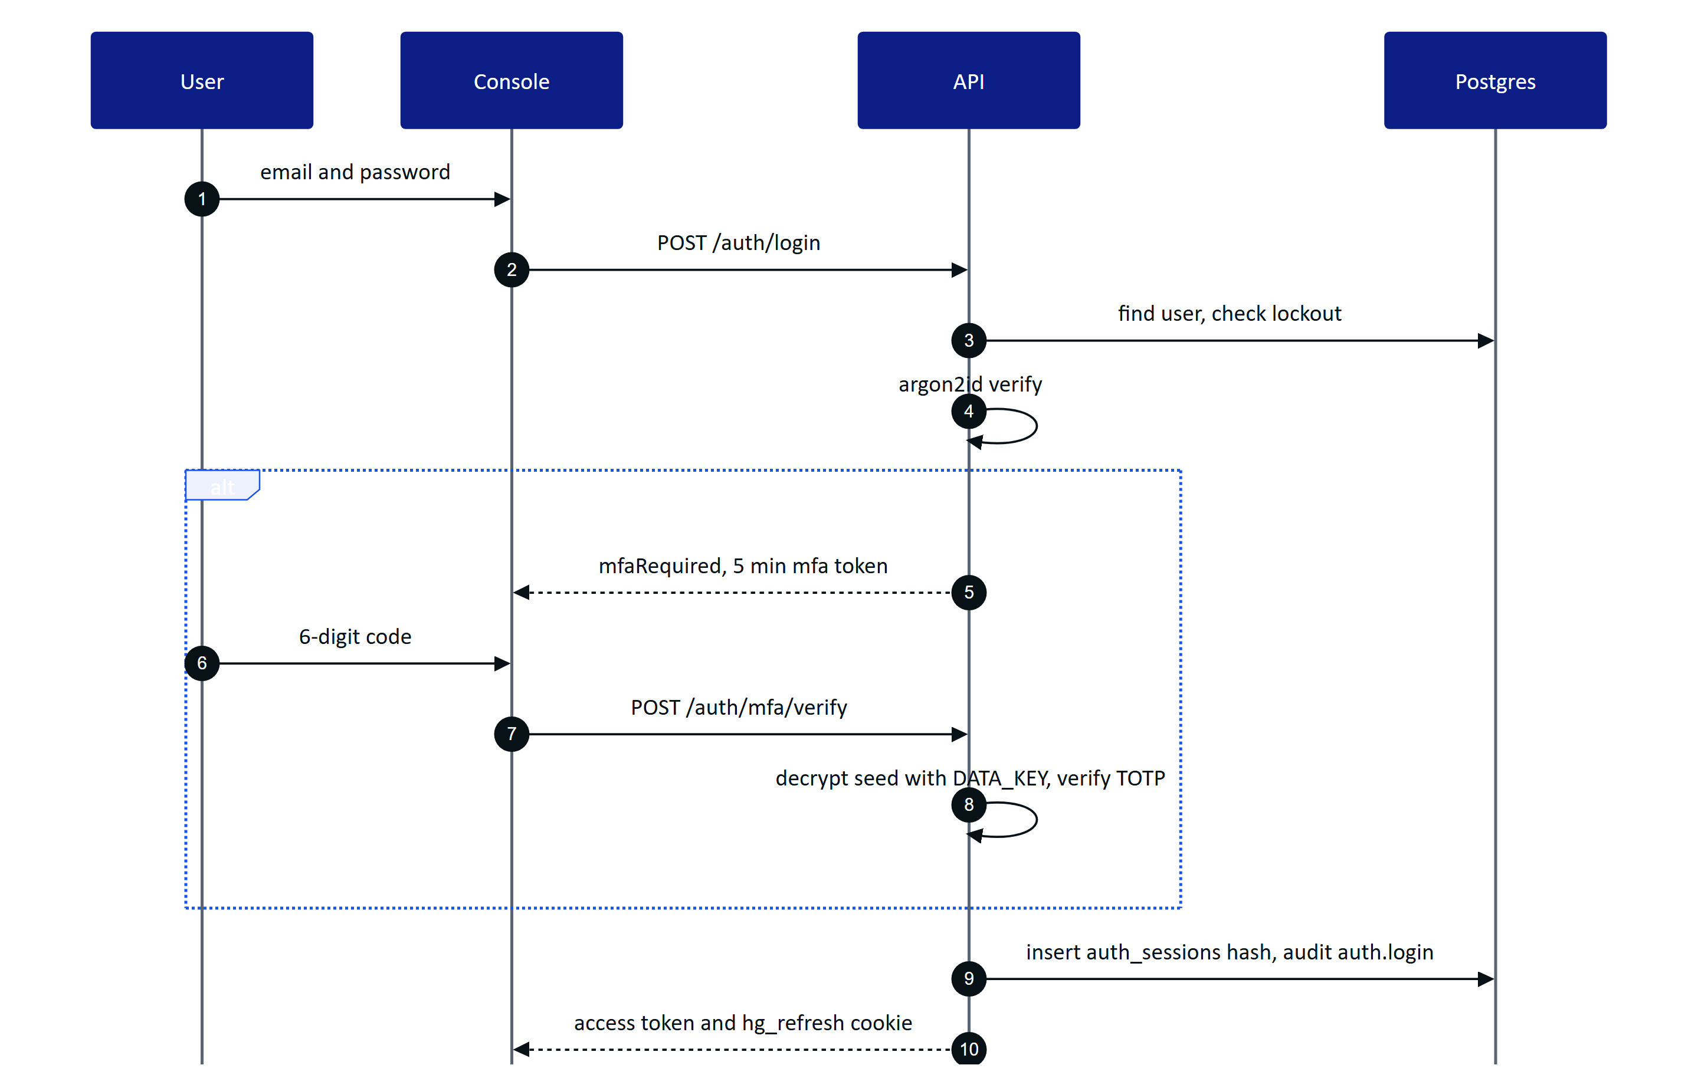
Figure 3. Password sign-in with optional TOTP second factor
Failed logins increment failed_logins; at five the account locks for 15 minutes and an auth.login_failed event is written each time. Unknown emails run a dummy argon2 verification so response time does not reveal which accounts exist. Passwords must be 12 to 200 characters and not a repeated character (passwordProblems).

5.3 Refresh rotation and reuse detection
Every refresh rotates the token within the same family. A rotated token presented again more than 30 seconds later (the grace window for several tabs) is treated as theft: the whole family is revoked and auth.refresh_reuse_detected is audited. Because each access token carries the family id and the API checks the family on every request, logout and reuse detection end outstanding access tokens immediately.
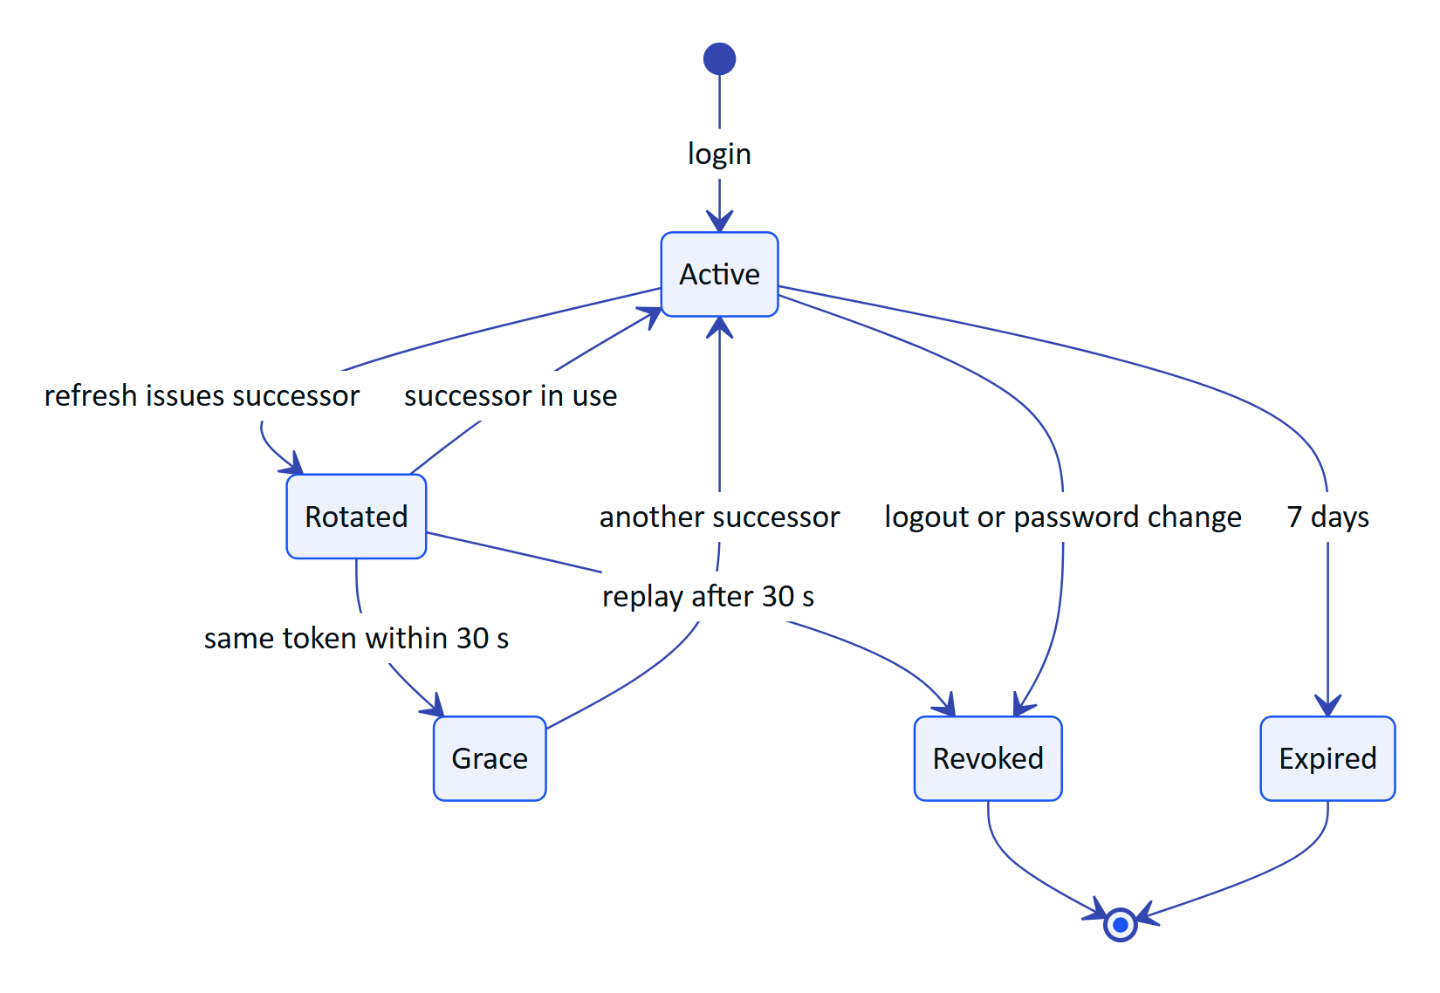
Figure 4. Refresh token family lifecycle
Table 8. Token inventory (apps/api/src/config.ts TTL, modules/auth.ts, modules/devices.ts)
Event | Effect | Status
Logout | Revokes the family | Built
Password change or reset | Revokes all sessions of the user | Built
Org switch | Revokes the current family, starts a new one | Built
Session list and remote revoke | GET and DELETE /auth/sessions | Built
User deactivated | Next request fails membership check | Built
SSO (SAML or OIDC) | Enterprise identity | Planned
Org-enforced MFA | Admin policy | Planned

6 Device and glasses security

6.1 Pairing
Glasses use a device-authorization flow modelled on OAuth device grant. The device requests a challenge and displays an 8-character code from an unambiguous alphabet (packages/domain/src/devices.ts); a signed-in user approves it on /pair. The QR code encodes only the /pair URL with the short code, never a credential.
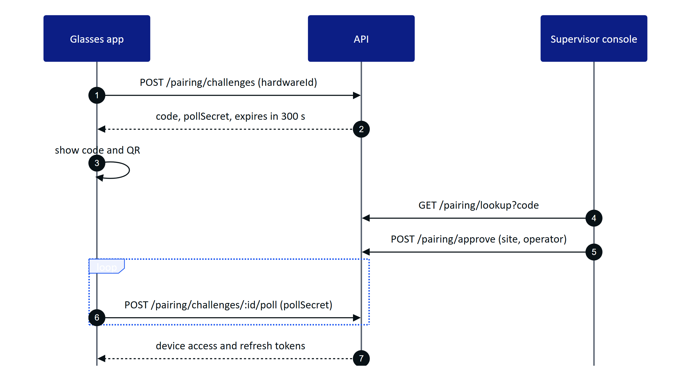
Figure 5. Glasses pairing with code approval
Table 9. Session control events
Control | Value | Source
Code length and alphabet | 8 characters, 30 symbols, CSPRNG | core/crypto.ts, packages/domain/src/devices.ts
Code TTL | 300 s | PAIRING_TTL_S
Code stored | SHA-256 only | pairing_challenges.code_hash
Poll secret | 32 random bytes, hashed, constant-time compare | modules/devices.ts
Rate limits | 10 challenges, 40 polls, 10 lookups and approvals per min | modules/devices.ts
Approver | User with device.pair and site scope | modules/devices.ts
Previous challenges | Cancelled when the same hardware id asks again | modules/devices.ts

6.2 Device lifecycle and lost devices
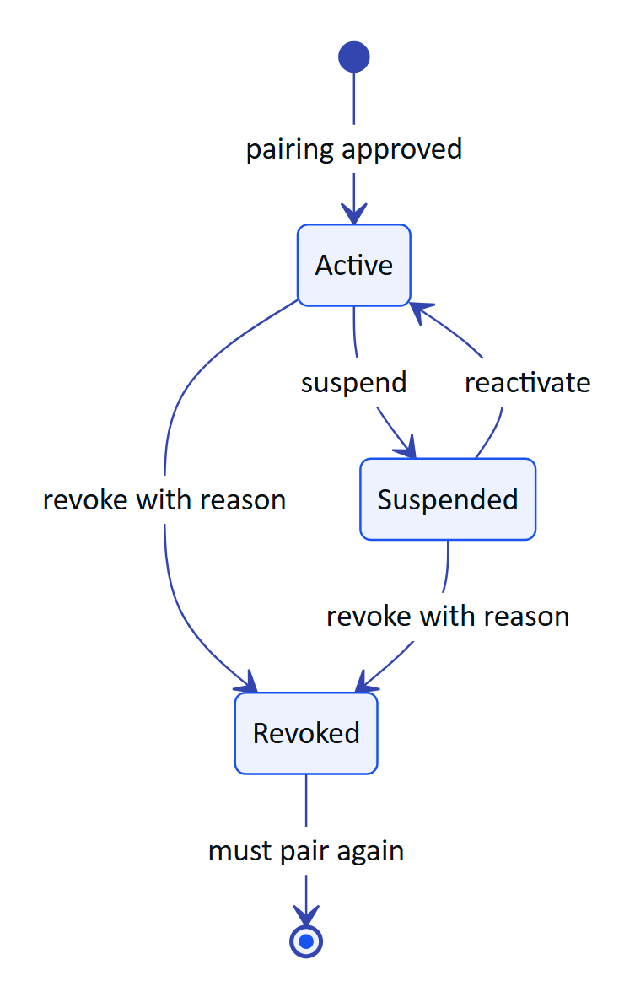
Figure 6. Device states and token effects
Every transition bumps devices.session_version, so outstanding device access tokens stop working at once. Revocation also ends all device sessions and releases the operator assignment, writes device.revoked with the reason, and pushes a device.revoked realtime event so an online device signs itself out.
Lost device procedure:
- The operator reports the loss to a supervisor.
- The supervisor revokes the device in the console with a reason (POST /devices/:id/revoke).
- If the phone also held a user session, the user signs in elsewhere and revokes it in the session list, or an admin deactivates and re-invites the user.
- If the phone is enrolled in MDM, IT issues a remote wipe.
- Security reviews audit_events for the device since the last known good time.
Table 10. Pairing controls
Storage of the device refresh token | Runtime | Status
Android Keystore AES-GCM (SecureStore.kt) | Hydris Field native app | Built
localStorage (apps/web/src/glasses/link.ts) | Glasses web app, including inside the bridge WebView | Partial (gap SEC-03)

7 Authorization

7.1 Roles and permissions
packages/domain/src/roles.ts is the single source of truth for six roles and 38 permissions. The API enforces it; clients only use it to decide what to show.
Table 11. Device credential storage
Role | Highlights
org_admin | All permissions
factory_manager | Plant model, gateways, alarm rules, members (not admins), devices, reports, audit log, audit-doc verify and approve
supervisor | Alarm workflow, inspection management and review, maintenance, devices
field_operator | Read, acknowledge alarms, execute inspections, request and execute maintenance, capture audit docs
maintenance_engineer | Maintenance execution and read access
viewer | Read-only

7.2 Layered enforcement
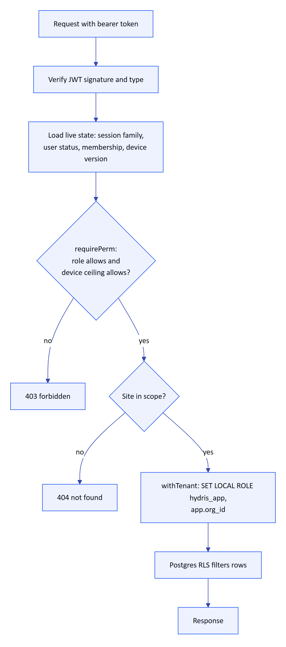
Figure 7. Every request passes three independent authorization layers
Out-of-scope records return 404, not 403, so their existence is not disclosed (requireSite in core/principal.ts).

7.3 Row-level security
Migration 0001_rls.sql enables and forces RLS on every tenant table with one policy:
CREATE POLICY tenant_isolation ON <table>
USING (hydris_tenant_ok(org_id)) WITH CHECK (hydris_tenant_ok(org_id));
-- hydris_tenant_ok: app.bypass = 'on' OR row_org = app.org_id
REVOKE UPDATE, DELETE ON audit_events FROM hydris_app;
Later migrations add the same policy to corrections, UI profiles (0003), realtime events (0006) and audit documents (0008), revoke UPDATE and DELETE on telemetry_corrections, and grant only SELECT, INSERT on audit_document_events. System work (login, pairing, jobs) uses withSystem, which sets app.bypass but still runs as hydris_app, so append-only grants hold everywhere.
WARNING
Owner and superuser connections bypass RLS. Production must connect as a runtime user that is a member of hydris_app and not the table owner. Today the same owner user runs migrations and the application.

8 API security
Table 12. Role summary
Control | Setting | Source | Status
Global rate limit | 600 per min per IP | app.ts | Built
Login, MFA | 10 per min | modules/auth.ts | Built
Password reset request | 5 per min | modules/auth.ts | Built
Refresh | 60 per min | modules/auth.ts | Built
Website inquiries | 5 per 10 min, honeypot, minimum fill time | modules/public.ts | Built
Voice assistant | 60 per min | modules/voice-assistant.ts | Built
Ingest | 1,200 per min, 500 readings per call | modules/telemetry.ts | Built
Body size | 1 MB default, 8 MB audit upload, 900 KB per page, 6 pages, 10 MB multipart | app.ts, modules/audit-docs.ts | Built
Input validation | zod on every body and parameter, 400 with field details | all modules | Built
Error hygiene | 5xx returns a generic message; stack only in logs | app.ts | Built
Shared rate-limit store | Limits are per instance |  | Planned

Table 13. API protections
Header | Value | Source
X-Content-Type-Options | nosniff | next.config.ts, helmet
Referrer-Policy | strict-origin-when-cross-origin | next.config.ts
Permissions-Policy | camera=(self), microphone=(), geolocation=() | next.config.ts
X-Frame-Options | DENY, SAMEORIGIN for glasses and simulator | next.config.ts
Helmet defaults (HSTS and others) | On, CSP off | app.ts
X-Powered-By | Removed | poweredByHeader: false
Content Security Policy | None | Planned

NOTE
Permissions-Policy sets microphone=(), which disables the microphone for the site's own pages. That may block the browser speech engine on /glasses; the Meta DAT speech path does not use the browser microphone. Verify and, if needed, set microphone=(self) for the glasses routes only.

Fastify runs with trustProxy: true. On Vercel the client address comes from the platform's x-forwarded-for; on a container deployment without a trusted proxy, a client could spoof the header and evade per-IP limits. Set trustProxy to the load balancer address in Topology B and C.

9 Secrets management
Table 14. Security headers
Secret | Purpose | Rotation impact | Store
JWT_SECRET | Signs all JWTs | All users and devices must refresh; MFA steps in flight fail; inquiry IP hash salt changes | Vercel env, production scope
DATA_KEY | Encrypts MFA seeds | Requires re-encryption of every mfa_secret_enc | Vercel env plus offline escrow
CRON_SECRET | Authorizes /api/cron | Update Vercel cron header | Vercel env
ANTHROPIC_API_KEY | AI features | None | Vercel env
BLOB_READ_WRITE_TOKEN | Attachment storage | Reconnect store | Injected by Vercel
DATABASE_URL | Database credentials | Rotate in Neon, redeploy | Injected by Vercel
Gateway keys | Ingest | Issue new key, revoke old | Hash only in DB
Android upload key, DAT token | Mobile release | Play key reset process | CI environment secret (Planned)

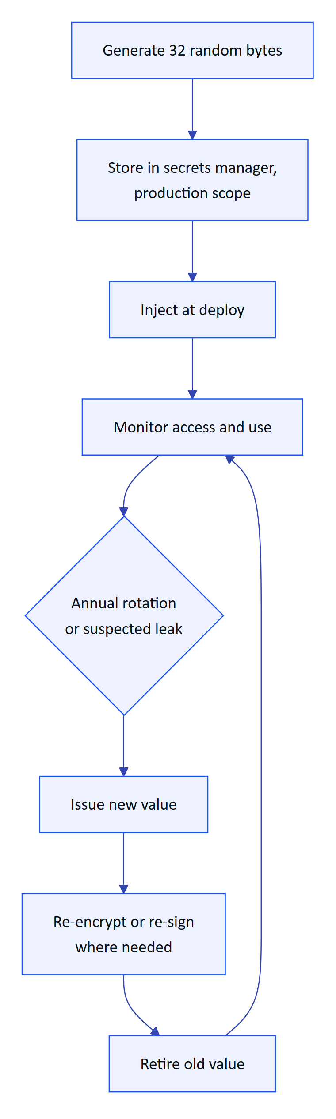
Figure 8. Target secret lifecycle
Rules: no secret in the repository or NEXT_PUBLIC_*; preview deployments use their own secrets; demo secrets in DEMO_SECRETS are public and only used in demo mode; annual rotation of JWT_SECRET and CRON_SECRET with a planned re-encryption tool for DATA_KEY (Planned).

10 Mobile security
Table 15. Secret inventory
Control | Hydris Field (apps/android) | Glasses bridge (apps/glasses-bridge-android)
Credential storage | Keystore AES-256-GCM SecureStore, cookies persisted encrypted | WebView localStorage (gap)
Backup | allowBackup="false" | allowBackup="false"
Minimum OS | Android 12 (SDK 31) | Android 12 (SDK 31)
Code shrinking | R8 on release | Not configured
Release signing | Debug key today (gap) | Debug build distributed
Cookie scope | Sent only to the configured host | n/a
Certificate pinning | Planned | Planned
Play Integrity attestation | Planned | Planned
WebView hardening | n/a | Origin allow-list and per-origin permission grants Planned
Cleartext traffic | Default (blocked on SDK 28+) | Default

Planned hardening for the bridge: override shouldOverrideUrlLoading to keep navigation on the Hydris origin, grant WebView camera permission only for that origin, and move the device refresh token behind a native bridge call backed by the Keystore so the web page never holds it.

11 AI safety

11.1 What is sent to Anthropic
AI features are enabled only when ANTHROPIC_API_KEY or ANTHROPIC_AUTH_TOKEN is set (visionAvailable() in core/vision-extract.ts). Without a key, audit scans keep on-device OCR results and the assistant uses the deterministic rules engine.
Table 16. Mobile security controls
Feature | Data sent | Model | Trigger
Audit scan enhancement | Page images (up to 6), optional operator hint | claude-opus-5-5 | User presses enhance, before review starts
Voice assistant | Question text (max 500 chars), up to 8 history turns, tool results with tenant data | claude-opus-5-5 | /assistant/ask

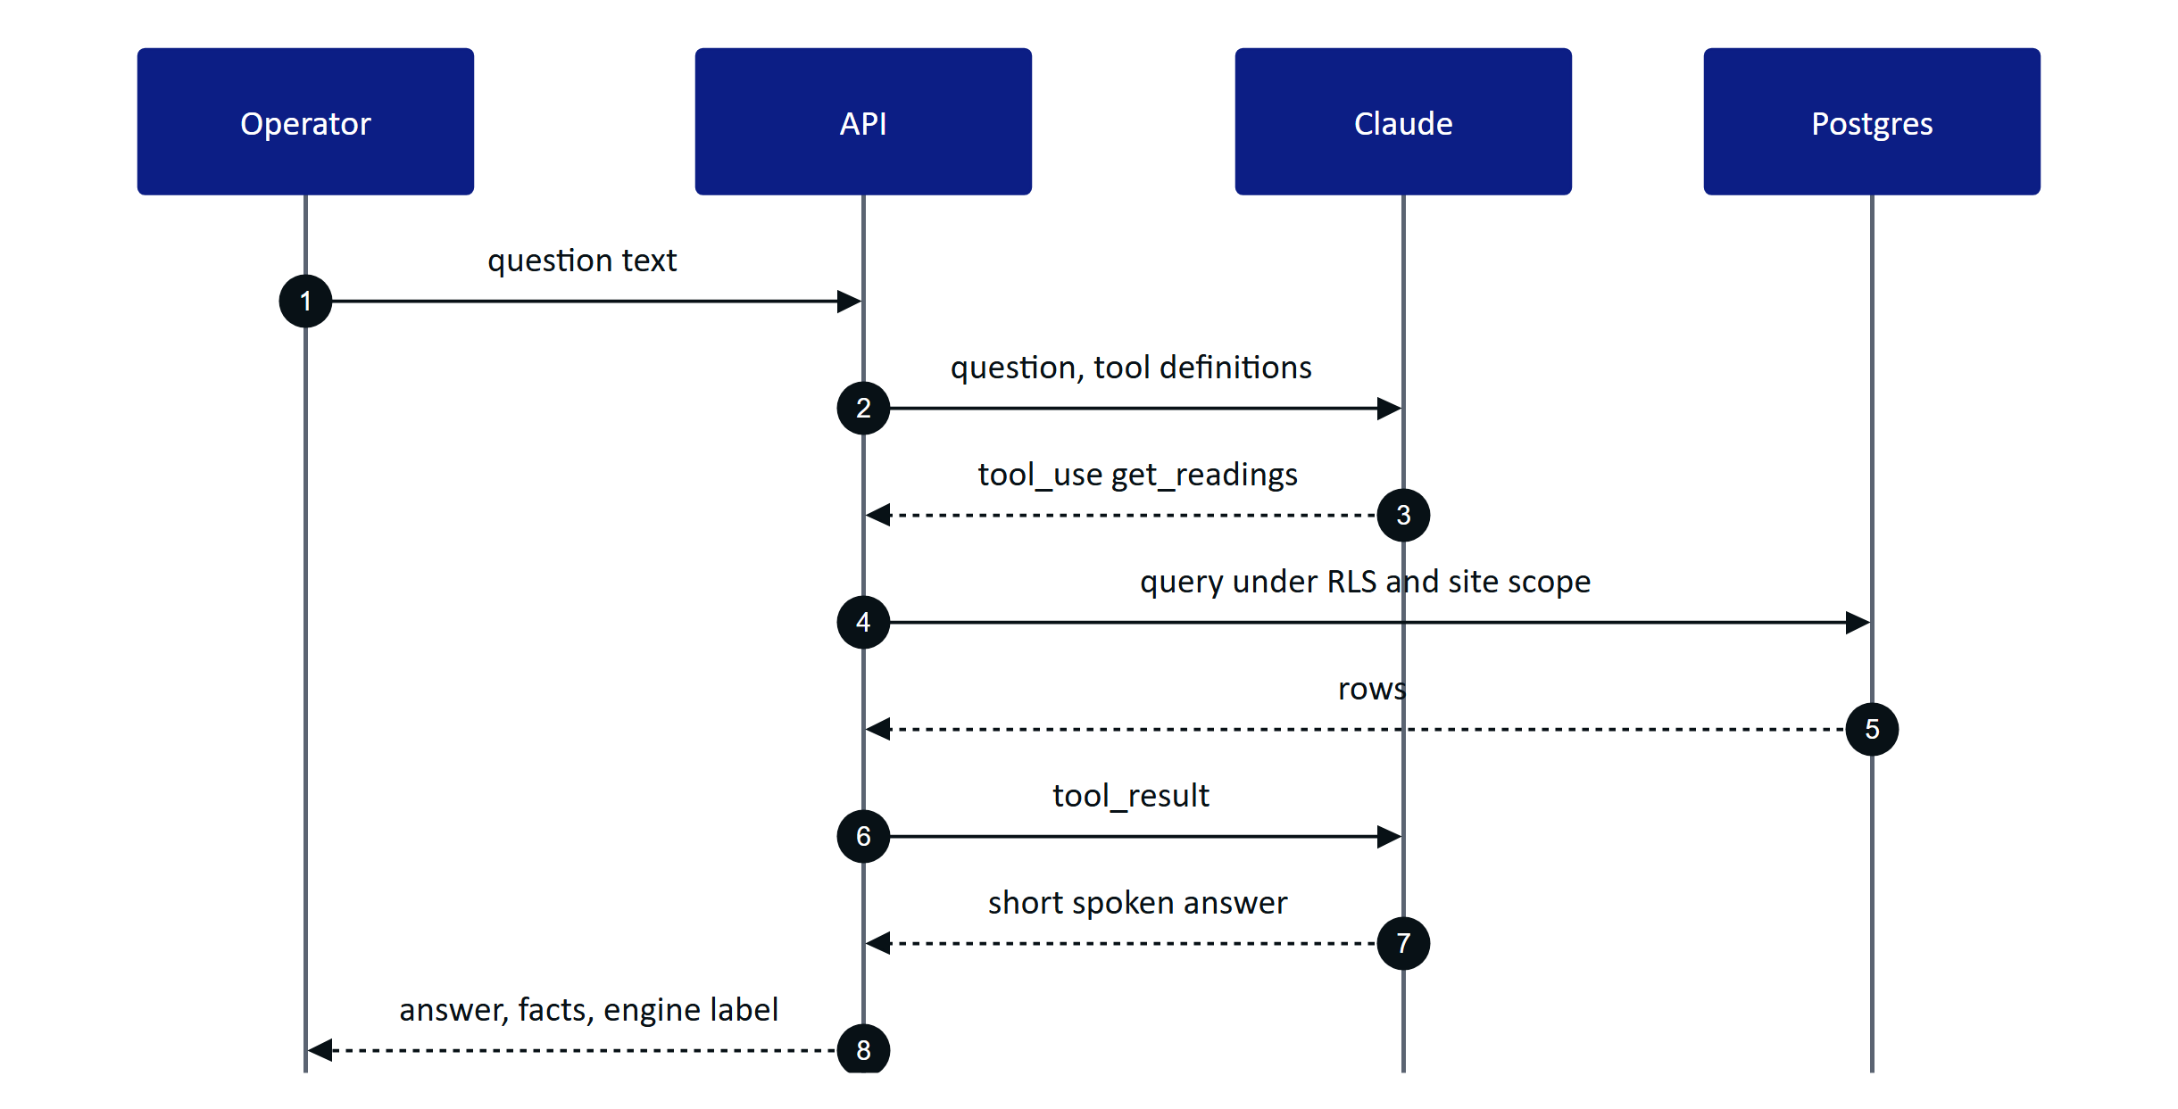
Figure 9. Grounded voice answer: the model only sees data returned by tenant-scoped tools

11.2 Controls
Table 17. Data sent to the AI provider
Risk | Control | Status
Hallucinated values | System prompt allows only tool values; facts returned with source and time; rules fallback never guesses | Built
Cross-tenant data in prompts | Tools run inside the caller's tenant transaction and site scope | Built
Prompt injection from scanned text | Vision output is a strict schema of fields and tables, not instructions; values are cross-checked with on-device OCR; nothing is executed from extracted text | Built
Unreviewed AI output becoming a record | Every field must be confirmed or corrected; flagged items block verification; a different approver signs off | Built
Unsafe operational advice | Prompt says Hydris never operates equipment and points to procedures and supervisors | Built
Excess data to the provider | Per-org opt-out, AI usage log, zero-retention terms | Planned

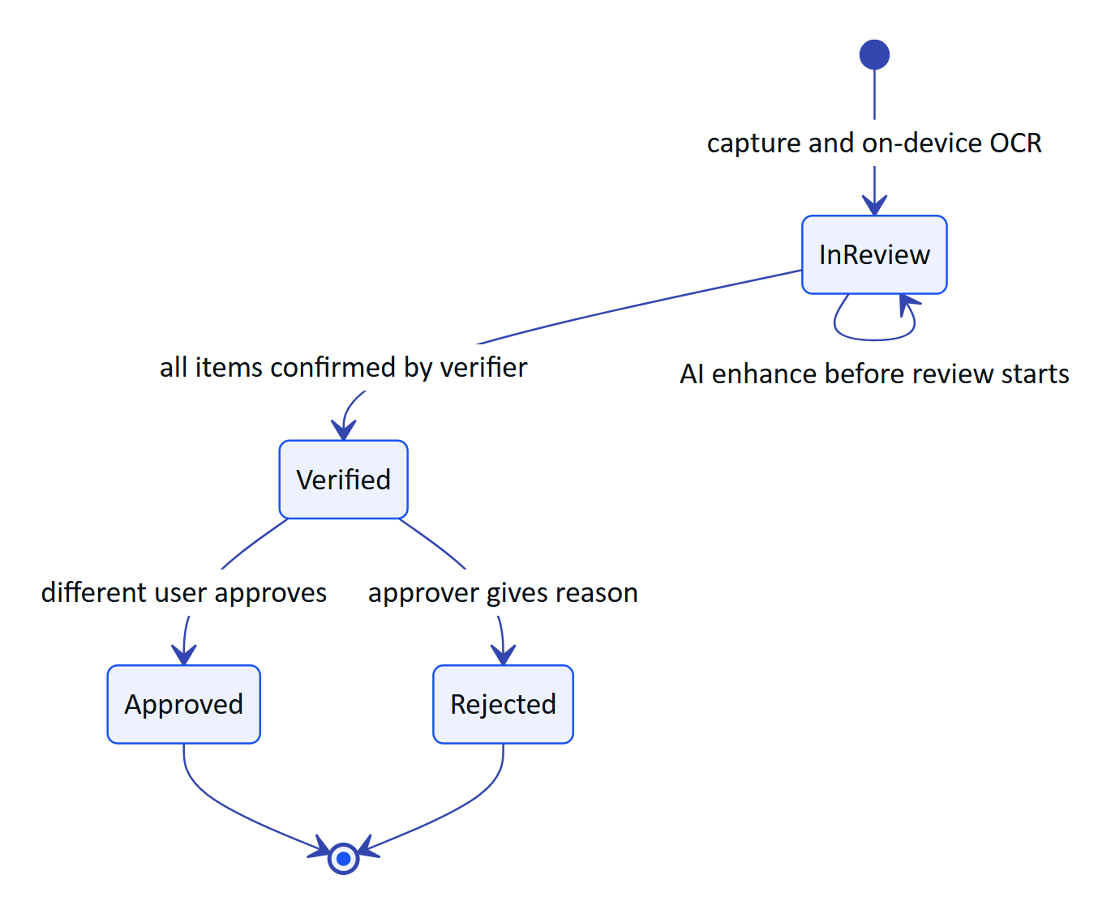
Figure 10. Audit document states: AI output becomes a record only after two people

12 Camera and bystander privacy
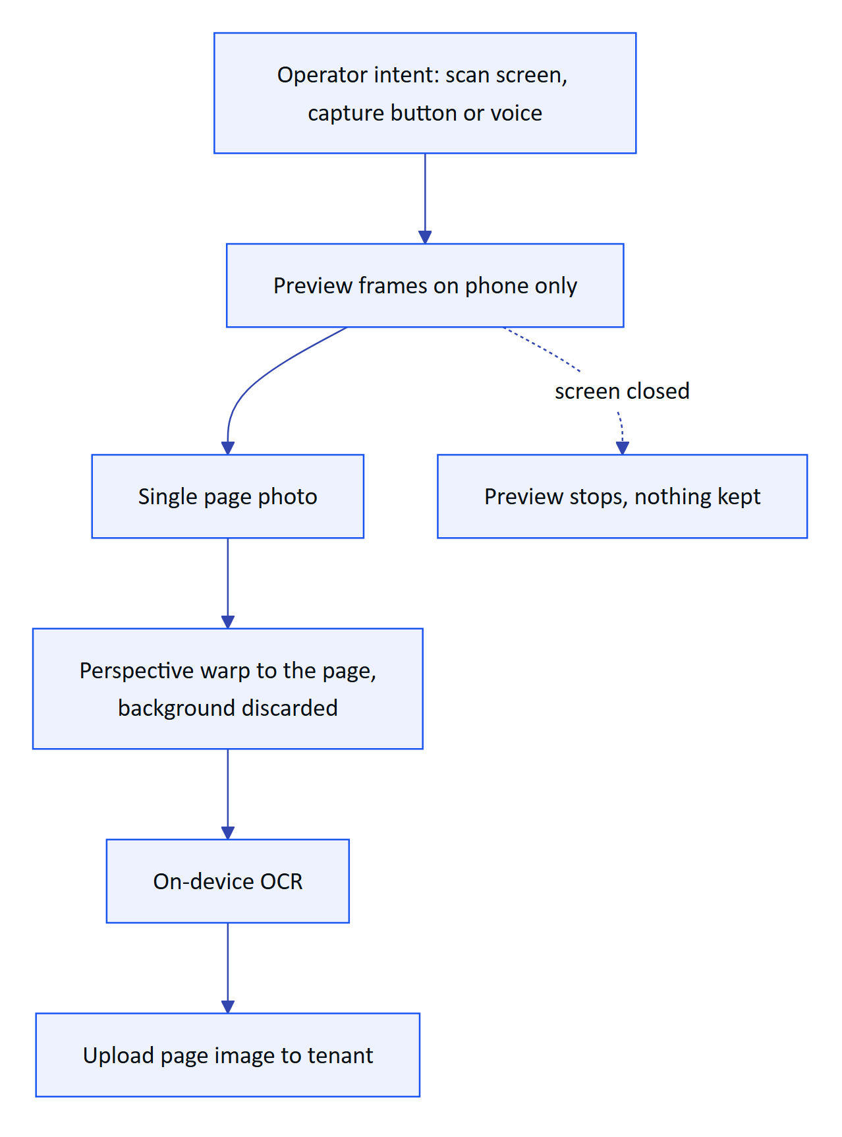
Figure 11. Camera use happens only on explicit intent
Table 18. AI safety controls
Commitment | Status
No background or continuous recording; no video stored | Built
Preview frames stay on the phone; only the final page is uploaded | Built
Meta glasses capture LED cannot be disabled by apps (vendor firmware) | Vendor control
Guided capture crops to the page quad | Built
Wake phrase matched on transcripts; only text after "Hey Hydris" is sent; audio never uploaded to Hydris | Built
Browser speech engines may send audio to the browser vendor | Disclosed; prefer DAT speech
Face and badge redaction before upload | Planned
Camera-free zones per site | Planned
Site signage and works council consultation | Customer process

13 Worker privacy and monitoring ethics
Hydris records who did what to a plant record because regulators require it. It is not a productivity surveillance tool, and we design to keep it that way.
- Device last_seen_at and last_ip exist for connectivity and security, not attendance. No location tracking.
- No continuous audio or video. No keystroke or gaze analytics.
- Reports on individual performance are not built and are not on the roadmap; aggregated workload views will be site-level only.
- Workers can see their own actions in the audit log through their supervisor; access requests are handled under DPDP and GDPR rights.
- Customers agree in the DPA not to use Hydris data for disciplinary monitoring without a lawful basis and worker consultation.

14 Compliance mapping
The table maps requirements to product controls. It is a mapping and a target, not a certification.
Table 19. Camera and bystander commitments
Framework | Relevant requirements | Hydris controls | Position
India DPDP Act 2023 and DPDP Rules 2025 | Notice and consent, security safeguards, breach notice to the Board and principals, erasure, retention limits | Consent version on inquiries, encryption and RLS, audit trail | Partial; retention and rights tooling Planned
CPCB and SPCB consent conditions, OCEMS guidance | Unaltered, retrievable monitoring records | Provenance, append-only corrections, CSV export, freshness | Mapping; Hydris is not the regulatory feed
CERT-In Directions 2022 | 6-hour incident reporting, 180-day logs in India | Incident plan; log drain Planned | Target
ISO/IEC 27001:2022 | ISMS and Annex A controls | Many technical controls in code | Target: ISMS build 2027
SOC 2 | Security, availability, confidentiality criteria | Same | Target: Type I after first commercial year
IEC 62443 | Zones and conduits, secure development | Read-only, outbound-only conduit from the DMZ gateway | Mapping; 4-1 practices as target
GDPR (exports, EU users) | Lawful basis, DPA, subprocessors, 72-hour breach notice | DPA, subprocessor list | Mapping

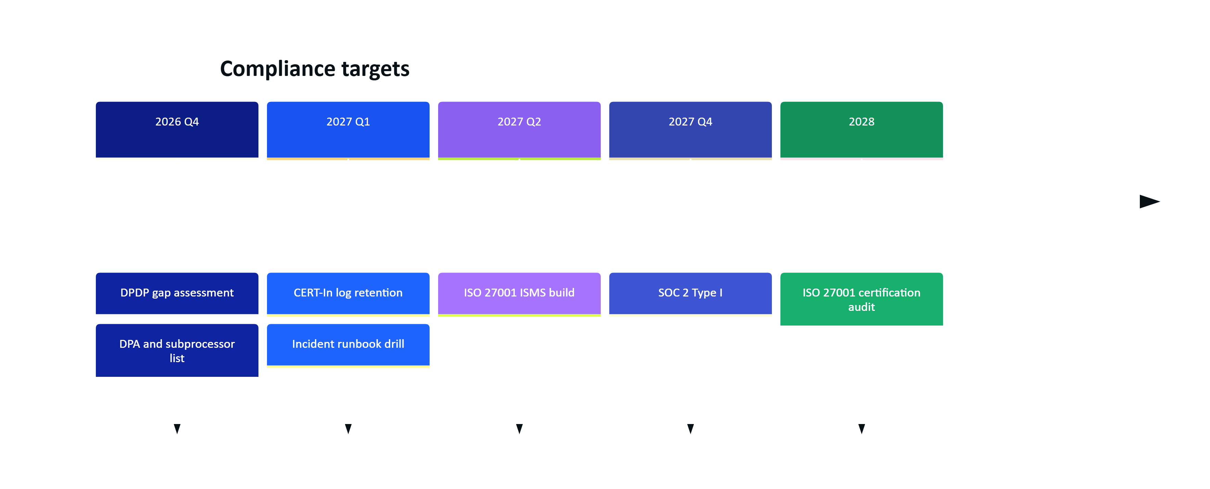
Figure 12. Compliance roadmap (targets)

15 Retention schedule
Retention below is the recommended default, configurable per organization (Planned). Today no purge job exists except realtime_events (1 day).
Table 20. Compliance mapping (targets, not certifications)
Data | Current | Recommended
Telemetry readings | Indefinite | Raw 2 years online, then archive; discharge data at least 5 years or per consent
Audit events, audit document events, alarm history | Indefinite, append-only | At least 7 years, then WORM export
Audit page images | Indefinite in Postgres | Object storage with lifecycle per record retention
Sessions, device sessions, pairing challenges | Not purged | Purge 30 days after expiry
Mail outbox (contains reset links) | Indefinite | Purge after send or 7 days
Inquiries | Indefinite | 24 months or on consent withdrawal
Realtime events | 1 day | Keep
Logs | Vercel default | 180 days in India for Indian tenants

16 Audit logging
Table 21. Retention schedule
Category | Example actions
Authentication | auth.login, auth.login_failed, auth.logout, auth.mfa_enabled, auth.password_reset, auth.refresh_reuse_detected, auth.session_revoked
Membership | member.invitation_accepted, role and scope changes
Devices | device.pairing_denied, device.suspended, device.revoked, device.refresh_reuse_detected
Records | auditdoc.verified, auditdoc.approved, auditdoc.rejected, telemetry corrections
Platform | organization.created, organization.suspended

Each event records org, actor user or device, action, entity, summary, metadata and IP (audit() in core/services.ts). Admins and managers read it through GET /api/audit. Planned: hash chaining, export to WORM storage and SIEM forwarding.

17 Vulnerability management
Table 22. Audit event catalogue (examples)
Activity | Cadence | Status
Dependency audit and updates | Weekly, CI gate on high and critical | Planned
Static analysis (CodeQL) and secret scanning | Every PR | Planned
Third-party penetration test | Before first commercial customer, then yearly | Planned
Responsible disclosure address and security.txt | Ongoing | Planned

Table 23. Vulnerability management
Severity | Fix target
Critical | 72 hours
High | 14 days
Medium | 60 days
Low | Next planned release

18 Incident response
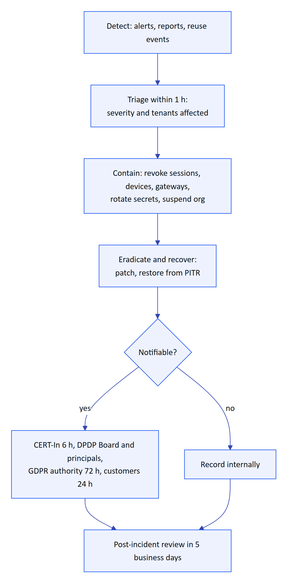
Figure 13. Incident response flow
Table 24. Remediation targets
Severity | Definition | Response | Customer notice
SEV1 | Confirmed cross-tenant exposure, data breach or secret compromise | Immediate, all hands | Within 24 h
SEV2 | Exploitable vulnerability or prolonged outage | Within 1 h | Within 48 h if affected
SEV3 | Contained issue, no data exposure | Same business day | Release notes
SEV4 | Hardening finding | Backlog | None

Containment tools already built: session revocation (/auth/sessions), device revoke, gateway revoke, organization suspension (/platform/organizations/:id/status), and JWT_SECRET rotation to sign everyone out.

19 Security roadmap
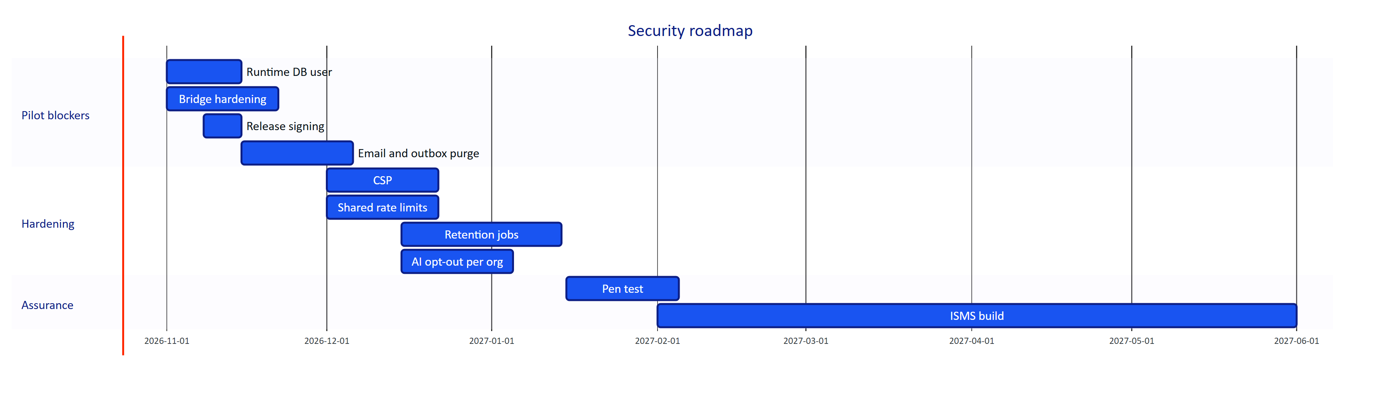
Figure 14. Security roadmap

20 Known gaps register
Table 25. Incident severity
ID | Gap | Likelihood | Impact | Rating | Plan
SEC-01 | No CI security gates | High | Medium | High | CI with audit, CodeQL, secrets
SEC-02 | Email not wired; reset links in mail_outbox | Medium | Medium | Medium | Provider and purge
SEC-03 | Glasses web device refresh token in localStorage | Medium | High | High | Native Keystore bridge
SEC-04 | Audit page images base64 in Postgres | Low | Medium | Medium | Object storage, encryption
SEC-05 | No purge or retention jobs | High | Medium | High | Retention jobs
SEC-06 | E-signature (re-auth, meaning) not built | Medium | Medium | Medium | Signature step on approve
SEC-07 | Pairing code TTL 300 s with no attestation | Low | Medium | Low | Shorter TTL, attestation
SEC-08 | Bridge WebView: open navigation, blanket permission grant | Medium | High | High | Origin allow-list
SEC-09 | CSP disabled | Medium | Medium | Medium | Strict CSP
SEC-10 | Owner connection could bypass RLS | Low | High | Medium | Separate runtime user
SEC-11 | Per-instance rate limits | Medium | Low | Low | Shared limiter
SEC-12 | Release APK signed with debug key | High | High | High | Upload key
SEC-13 | No per-org AI opt-out | Medium | Medium | Medium | Org setting

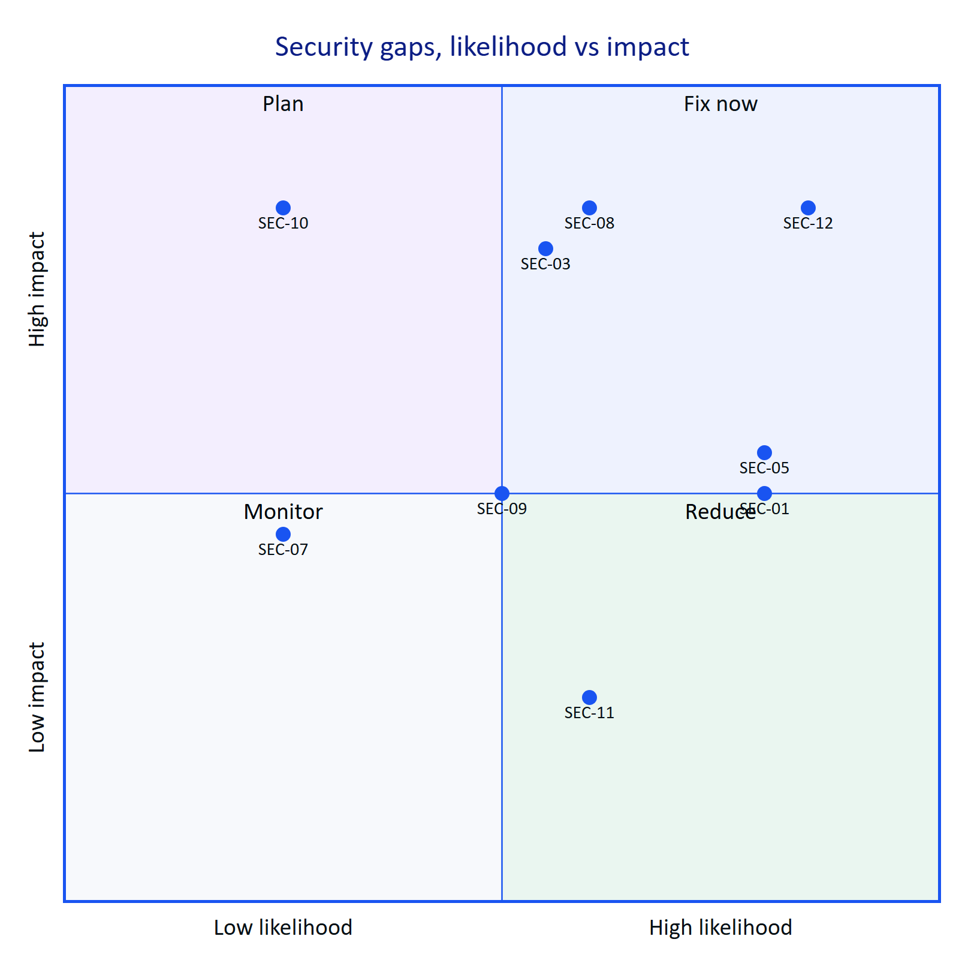
Figure 15. Gaps by likelihood and impact
DECISION
SEC-03, SEC-08, SEC-10 and SEC-12 block any pilot with real plant data. The remaining items are scheduled in the roadmap above.

